South Main Station Playground

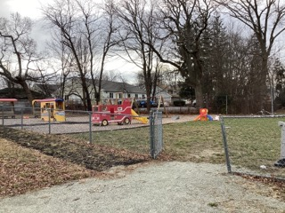
Town of Randolph
ADA Transition Plan
January 2023


560 Harrison Avenue, Boston, MA 02118
www.IHCDesign.org • info@IHCDesign.org
617-695-1225 voice

Background

The South Main Station Playground is located at 41 South Main Street by the Town Hall and Police Station building. A playground is southwest of the Town Hall and Police Station and a basketball court is on the northwest side of the building. There is one (1) entrance to the playground and there are two (2) entrances to the basketball court. The entrance on the south side of the basketball court connects to a set of stairs.

Note: See the Town Hall and Police Department reports for additional accessibility issues regarding the parking lot at this location.

Key Accessibility Issues

Playground
Accessibility issues include lack of an accessible route to and around the playground and lack of a compliant impact-attenuating surface under and around the play components.

Note: The Massachusetts Architectural Access Board (MAAB)
does not consider Engineered Wood Fiber (EWF) to comply with
its regulation requiring an accessible route to and around
playground equipment.

Basketball Court
Accessibility issues include handrails at the stairs that do not extend 12” past the bottom stair and an entry gate by the parking lot that requires excessive opening force.
*Note: IHCD is not providing costs for accessibility renovation to outdoor areas.

Additional Accessibility Issues
- Lack of an accessible route to at least one of the benches that are adjacent to the playground.

Best Practice and Inclusive Design
Best practice and inclusive design recommendations include elements that are not required in the standards but may create enhanced experiences for all users.
- Recommend providing a 36” min. by 48” min. stable and firm surface adjacent to at least one (1) bench by the playground positioned to allow a person using a wheeled mobility device and a person sitting on the bench to have their shoulders aligned in a manner that is substantially similar to what is shown in Figure 1.

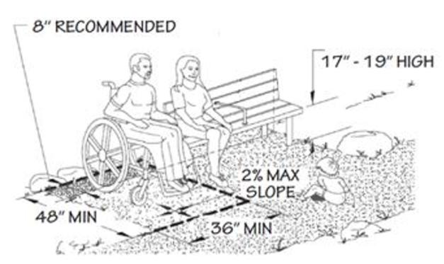
Figure 1

- Recommend providing a van accessible parking space near the accessible entry at the basketball court.

