Belcher Park and Cochato Camp House
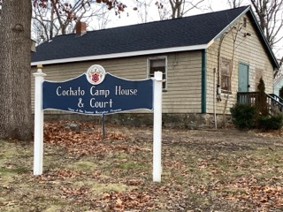
Town of Randolph
ADA Transition Plan
January 2023


560 Harrison Avenue, Boston, MA 02118
www.IHCDesign.org • info@IHCDesign.org
617-695-1225 voice/ tty

Background
Year Built: 2017
Belcher Park and Cochato Camp House are located at 60 Pleasant Street. Amenities include the Cochato Camp House, parking by the main entrance, a shed, a basketball court and a playground located on the east side of the Camp House. In addition, two (2) picnic pavilion areas are located by the parking area and an additional picnic pavilion, which was recently built as part of an Eagle Scout project, is located by Scum Pond north of building.

The main entrance, which is accessed by a set of stairs, is on the west side of the Camp House building and a ramp to the accessible side entrance is on the south side of building.

Key Accessibility Issues

Parking
Accessibility issues include lack of a van accessible parking space with a marked access aisle, identification sign with the International Symbol of Accessibility (ISA) and a designation sign with the words, “Van Accessible.”

Exterior Access Routes
Accessibility issues include lack of an accessible route to most park amenities including to the picnic pavilion by the pond, to
the shed and to the boundary of sport activity at the basketball court. Other accessibility issue include an exterior ramp that is not maintained in operable working condition and needs to be rebuilt.

Playground
Accessibility issues include lack of an accessible route to and around the playground and lack of a compliant impact-attenuating surface under and around the play components.

Note: The Massachusetts Architectural Access Board (MAAB) does not consider engineered wood fiber (EWF) to comply with its regulation requiring an accessible route to each play component and around the playground.

Kitchen
Accessiblity issues include include lack of a cooktop with knee and toe clearance positioned for a forward appraoch, lack of a wall oven with a retractable "bread board" type shelf, and lack of a sink with knee and toe clearance

Signage
Accessibility issues include lack of tactile designation and egress signs (with raised characters and braille) and designation signs not located along the wall on the latch side of the door. There is also lack of a directional sign at the inaccessible egress directing visitors to the nearest accessible egress and lack of a sign at the inaccessible entrance directing visitors to the ramped accessible entrance.

Toilet Rooms
Accessibility issues include lack of an accessible single-user toilet room. Other accessibility issues include the entry door which is narrower than allowed. The entry door also has hardware that requires tight grasping, pinching and twisting of the wrist.

Additional Accessibility Issues
- The threshold at the egress door leading to the exterior stairs at the Camp House and the threshold at the storage shed are higher than the maximum height allowed.
- The exterior handrails at the main entrance stairs have a noncompliant cross section and do not extend 12” beyond the bottom riser.
- Lack of an accessible picnic table at both picnic pavilion locations.

Order of Magnitude Cost Estimates
- Renovate toilet room: $24,604
- Renovate kitchen (including providing an accessible cooktop, wall oven and sink): $6,294
- Miscellaneous corrective actions (accessible door thresholds, signage, etc.): $1,342

Total: $32,240

*Note: IHCD is not providing costs for accessibility renovation to handrails or for renovations to outdoor areas.

Best Practice and Inclusive Design
Best practice and inclusive design recommendations include elements that are not required in the standards but may create enhanced experiences for all users.

- Recommend providing contrasting colored strips on the exterior stairs.
- Recommend providing a 48” min. stable, firm, and slip-resistant surface around at least one (1) accessible picnic table located on an accessible route at each location where picnic tables are provided in a manner that is substantially similar to what is shown in Figure 1.

Figure 1: Showing a stable, firm and slip-resistant surface around a picnic table to allow a person in a wheeled mobility device to maneuver around the picnic table.
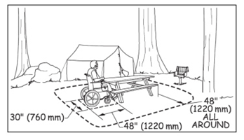

- Recommend providing the required van accessible parking space in a manner substantially similar to what is shown in Figure 2:

Figure 2: Showing an example of one way to designate accessible parking in an unpaved parking lot with accessible signage and accessible parking space requirements.
