Central Fire Station

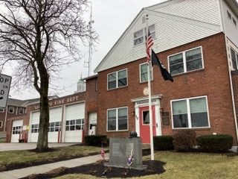
Town of Randolph
ADA Transition Plan
January 2023



560 Harrison Avenue, Boston, MA 02118
www.IHCDesign.org • info@IHCDesign.org
617-695-1225 voice

Background

Year Built: 1956 Year Renovated: 1998-1999

The Central Fire Station is a 3-story building located at 10 Memorial Parkway. There are two (2) entrances on the north and south sides of the building with one accessible entrance on the west side of the building. There are four (4) parking spaces on the south side of the building. Only the first floor is accessed by the public.

Areas on the first floor that are accessed by members of the public include an information counter near the north main entrance, the Deputy Chief, Fire Prevention and Code Enforcement Offices, and three (3) public toilet rooms.

Note: IHCD team only surveyed areas used by the public.

Key Accessibility Issues

Parking
Accessibility issues include the identification sign with the International Symbol of Accessibility (ISA) mounted lower than required and lack of the designation “Van Accessible” at the sign located at the van accessible parking space.

Exterior Access Routes and Ramp
Accessibility issues include excessive cross slopes and routes not maintained in operable working condition. In addition, the exterior ramp at the west accessible entrance has an excessive opening at the bottom landing and the ramp lacks edge protection on one side.

Signage
Accessibility issues include lack of designation signs, lack of tactile egress signs (with raised characters and braille) and lack of signs at the inaccessible entrances and egresses directing visitors to the nearest accessible entrance and egress. Additional issues include lack of a sign with the International Symbol of Accessibility (ISA) at the accessible single-user toilet room, and lack of signs directing visitors to the nearest accessible toilet room at the two (2) inaccessible toilet rooms located in the service bay area.

Single-User Toilet Rooms
Accessibility issues include a mirror mounted higher than the maximum height allowed and a storage shelf that protrudes into the circulation path in the accessible single-user toilet room. Two (2) single-user toilet rooms in the service bay area lack the minimum required turning space.

Additional Accessibility Issues
- A service counter is higher than the maximum height allowed.
- An emergency kit near Deputy Chief’s office protrudes into the circulation path.

Order of Magnitude Cost Estimates
- Renovate and provide signage: $2,088
- Miscellaneous corrective actions (renovate toilet rooms, cane-detectible barrier, service counter, etc.): $1,698

Total: $3,786
*Note: IHCD is not providing costs for accessibility renovation to outdoor areas.

