Stetson Hall

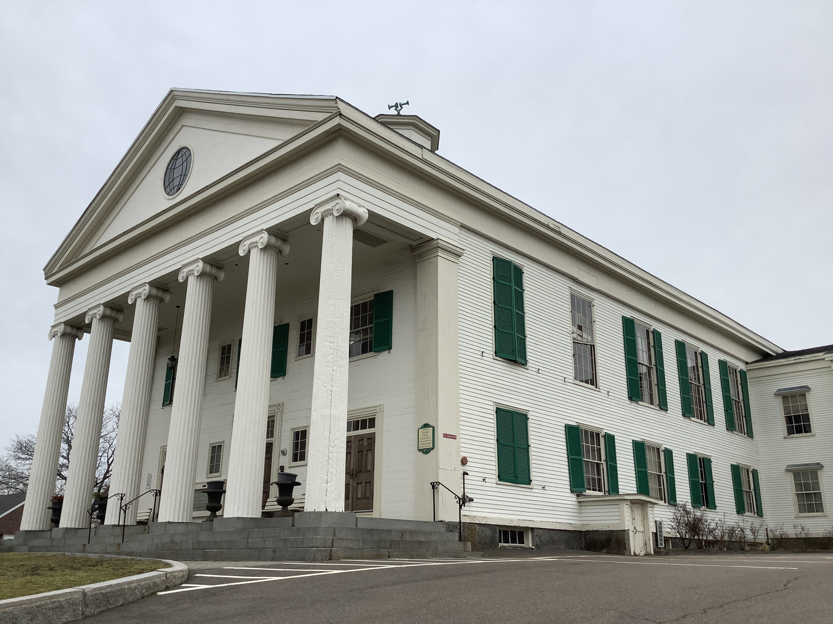

Town of Randolph
ADA Transition Plan
February 2023


560 Harrison Avenue, Boston, MA 02118
www.IHCDesign.org • info@IHCDesign.org
617-695-1225 voice

Background

Year Renovated: 2009

Stetson Hall is located at 6 South Main Street. The three (3) story building includes an internal balcony and seating area overlooking a stage. The public accessible entrance is located on the southeast side of the building, and it can be accessed via a ramp. There is an additional inaccessible entrance on the northwest side of the building, and parking is provided in a parking lot on the building’s eastern and southern sides. Stetson Hall was added to the National Register of Historic Places in 2011.

Note: There are exceptions for alterations to qualified historic buildings and facilities under the ADA Standards. Those exceptions apply to accessible routes, entrances and toilet facilities. If alterations to a qualified historic building or facility to achieve program accessibility would threaten or destroy the historic significance of the building or facility, fundamentally alter the program, or result in undue financial or administrative burdens, the ADA regulations allow alternative methods to be used to achieve program accessibility. Alternative methods include using audio-visual materials to depict portions of the facility that cannot otherwise be made accessible.

On the first floor the Hall houses rented office space, a museum room, drinking fountains and men’s and women’s multi-user toilet rooms. On the second floor there is the Great Hall banquet area, men’s and women’s multi-user toilet rooms, drinking fountains, a family multi-user toilet room and a catering kitchen. The third floor provides access to a stage and to the balcony seating area. The banquet hall can be rented by members of the public.

The building’s floors are connected by a set of stairs. A second staircase connects the main entrance to the Great Hall. An elevator provides accessible vertical access to all floors and to the stage, but not to the internal balcony and seating area. There is no accessible vertical access to the balcony and seating area.

Note: IHCD team only surveyed the areas used by the public.

Key Accessibility Issues

Parking
Accessibility issues include lack of the designation "Van Accessible" at the International Symbol of Accessibility (ISA) identification sign that is located at the van accessible parking space, the identification signs are mounted lower than the minimum height required, and there is an excessive cross slope at one (1) access aisle.

Signage
Accessibility issues include lack of the International Symbol of Accessibility (ISA) at the main accessible entrance, lack of a directional sign from the inaccessible entrance directing visitors to the accessible main entrance, lack of tactile egress signs (with raised characters and braille) at egress doors, and lack of a directional sign at the inaccessible egress indicating the location of the nearest accessible egress. Additionally, there is lack of compliant designation signage (with braille and raised characters), lack of signs located on the latch side of the door and lack of a designation sign with a non-glare finish.

*Note: If the exit sign at the accessible egress (southeast egress) door is replaced with an illuminated exit sign, also provide an illuminated International Symbol of Accessibility (ISA).

Doors
Accessibility issues include multiple doors that require excessive opening force, doorways with thresholds higher than the maximum height allowed and lack of maneuvering clearance at three (3) doors.

Interior Access Routes
Accessibility issues include lack of an accessible route to the third (3rd) floor balcony seating area and lack of a cane-detectable barrier at the automated external defibrillator (AED) in the Great Hall.

Stairs
Accessibility issues with exterior stairs include handrails located lower than the minimum height required, lack of handrail extensions at the top and bottom of the stairs, lack of continuous handrails at the main entrance stairs and lack of handrails on both sides at the secondary entrance stairs. Accessibility issues with interior stairs include lack of handrail extensions, handrails located lower than the minimum height required, lack of stair treads in operable working condition and lack of continuous handrails. There were also instances in the stairway that lacked the minimum required vertical clearance.

Toilet Rooms
Accessibility issues at the men's and women's multi-user toilet rooms include lack of the required clear floor space at the toilet due to the location of trash cans, doors with malfunctioning self-closing hinges and lack of a door pull on each side of the accessible compartment door. Additionally, at the family multi-user toilet room, the accessible compartment door lacks a self-closing hinge and lacks a door pull on both sides. Also, all the paper towel dispensers in the toilet rooms lack cane-detectable barriers and two (2) paper towel dispensers lack clear floor space.

Kitchens and Kitchenettes
Accessibility issues include lack of an accessible cooktop, lack of a wall oven, lack of a sink and counter space with knee and toe clearance positioned for a forward approach, lack of a sink with a depth no greater than 8” and the freezer door is located higher than the maximum allowed.

Additional Accessibility Issues
- Lack of an assistive listening system in the Great Hall.

*Note: Where a sound system, microphone and/or speaker are integral to the use of the space an assistive listening system (ALS) must be provided.

Order of Magnitude Cost Estimates
- Renovate the kitchen: $11,774
- Miscellaneous corrective actions (assistive listening system, egress signs, cane-detectable barrier under paper towel dispensers, lower door thresholds, etc.): $15,339

Total: $27,113
*Note: IHCD is not providing costs for accessibility renovation to outdoor areas.

Best Practice and Inclusive Design
Best practice and inclusive design recommendations include elements that are not required in the standards but may create enhanced experiences for all users.
- Recommend providing signage with raised characters and braille on the latch side of the door at all permanent rooms that lack designation signage.
- On the second (2nd) floor outside of the elevator, recommend providing a directional sign indicating where the stage is located.

