Imagination Station Playground

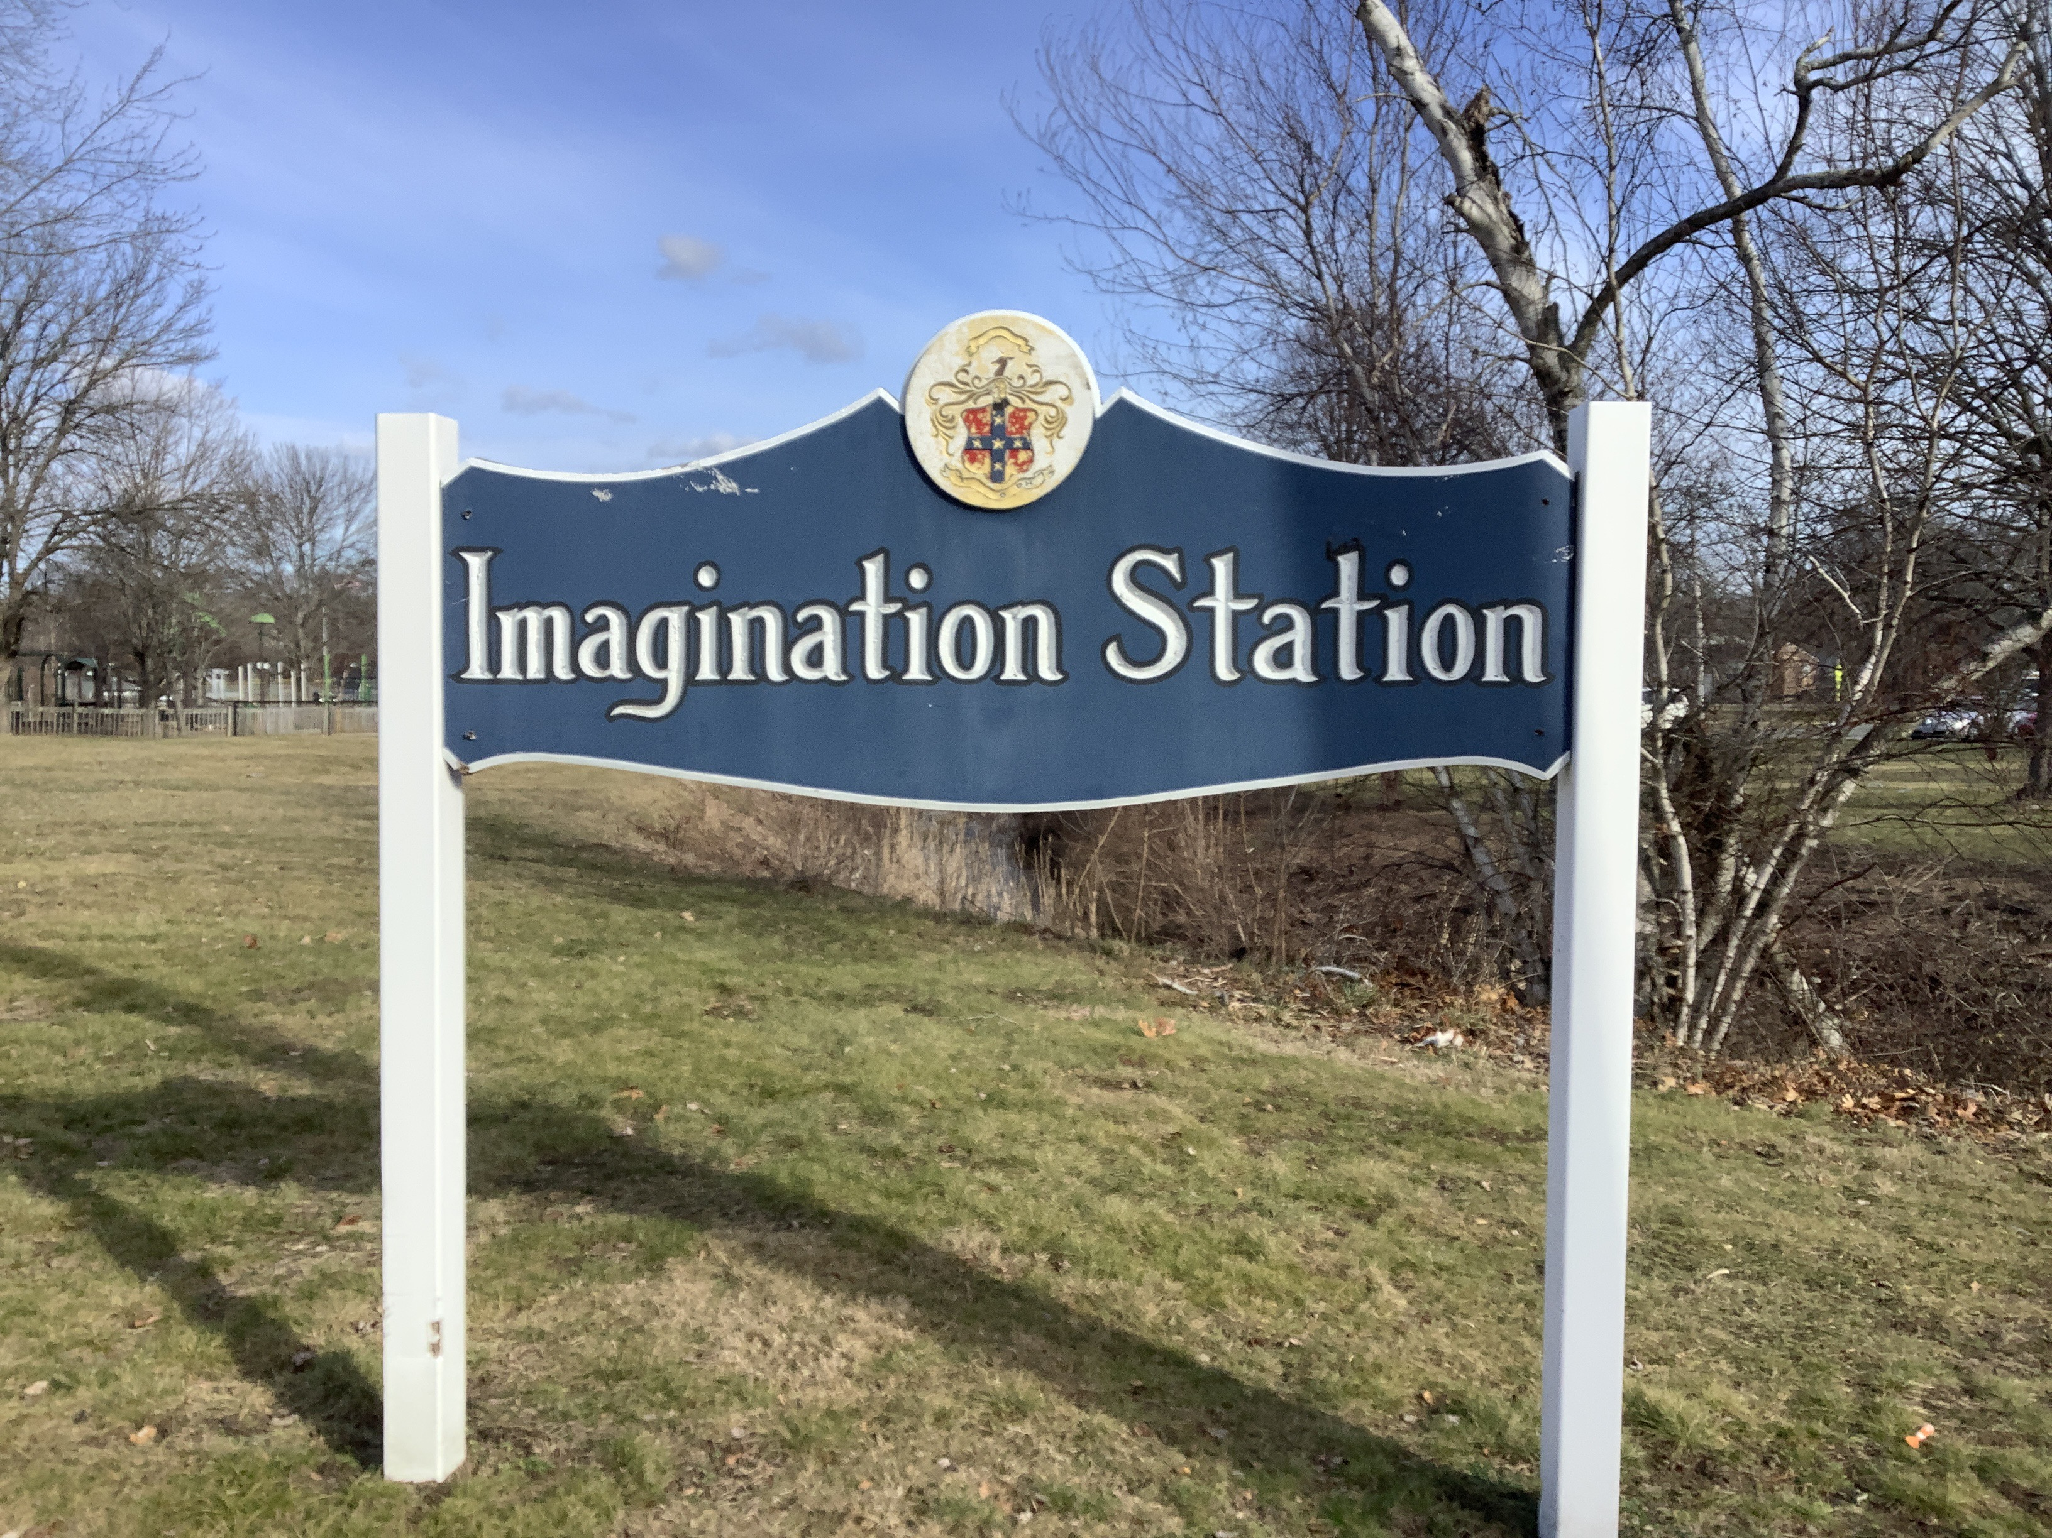

Town of Randolph
ADA Transition Plan
January 2023


560 Harrison Avenue, Boston, MA 02118
www.IHCDesign.org • info@IHCDesign.org
617-695-1225 voice

Background

Year Renovated: 2016

Imagination Station Playground is located at 128 Pleasant Street, east of the Randolph Intergenerational Community Center (RICC). The playground features two (2) play areas, a pavilion, picnic tables, benches, and a splash pad. There are two (2) accessible parking spaces by the north end of the site and a parking lot that is shared with the Randolph Intergenerational Community Center (RICC). There is also additional parking at the Joseph J. Hart Memorial Park.

Note: A nearby gazebo west of the playground was not part of the survey area.

Key Accessibility Issues

Parking
Accessibility issues include lack of the designation "Van Accessible" on the sign located at the van accessible parking space and both identification signs with the International Symbol of Accessibility are mounted lower than the minimum height allowed. In addition, striping at the accessible spaces is faded and not maintained in operable working condition.

Note: Parking at the Randolph Intergenerational Community Center (RICC) is covered in the RICC narrative report and survey catalog.

Play Areas
Accessibility issues at both playgrounds include lack of a compliant impact-attenuating surface under and around the play components. Additionally, the older-child play area lacks an accessible route to and around the playground.

Note: The Massachusetts Architectural Access Board (MAAB) does not consider engineered wood fiber (EWF) to comply with its regulation requiring an accessible route to each play component and around the playground.

Exterior Access Routes
Accessibility issues include lack of an accessible route to one (1) picnic table and one (1) bench near the playground and one (1) picnic table and (1) one bench near the gazebo.

Additional Accessibility Issues
- Lack of at least one (1) accessible picnic table by the gazebo, playground and inside the playground.
*Note: IHCD is not providing costs for accessibility renovation to outdoor areas.

Best Practice and Inclusive Design
Best practice and inclusive design recommendations include elements that are not required in the standards but may create enhanced experiences for all users.
- Recommend providing a 36” min. by 48” min. stable and firm surface adjacent to at least one (1) bench by the playground and the gazebo positioned to allow a person using a wheeled mobility device and a person sitting on the bench to have their shoulders aligned in a manner that is substantially similar to what is shown in Figure 1.

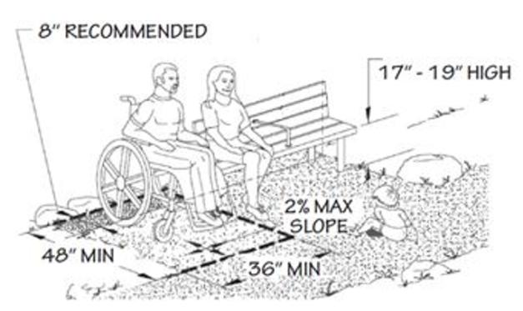
Figure 1

- Recommend providing a 48” min. stable, firm, and slip-resistant surface around at least one (1) accessible picnic table located on an accessible route at each location where picnic tables are provided in a manner that is substantially similar to what is shown in Figure 2.

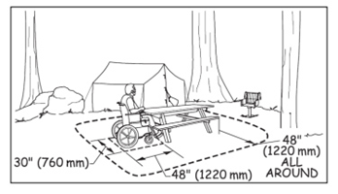
Figure 2: Showing a stable, firm and slip-resistant surface around a picnic table to allow a person in a wheeled mobility device to maneuver around the picnic table.

