Friendly Food Pantry

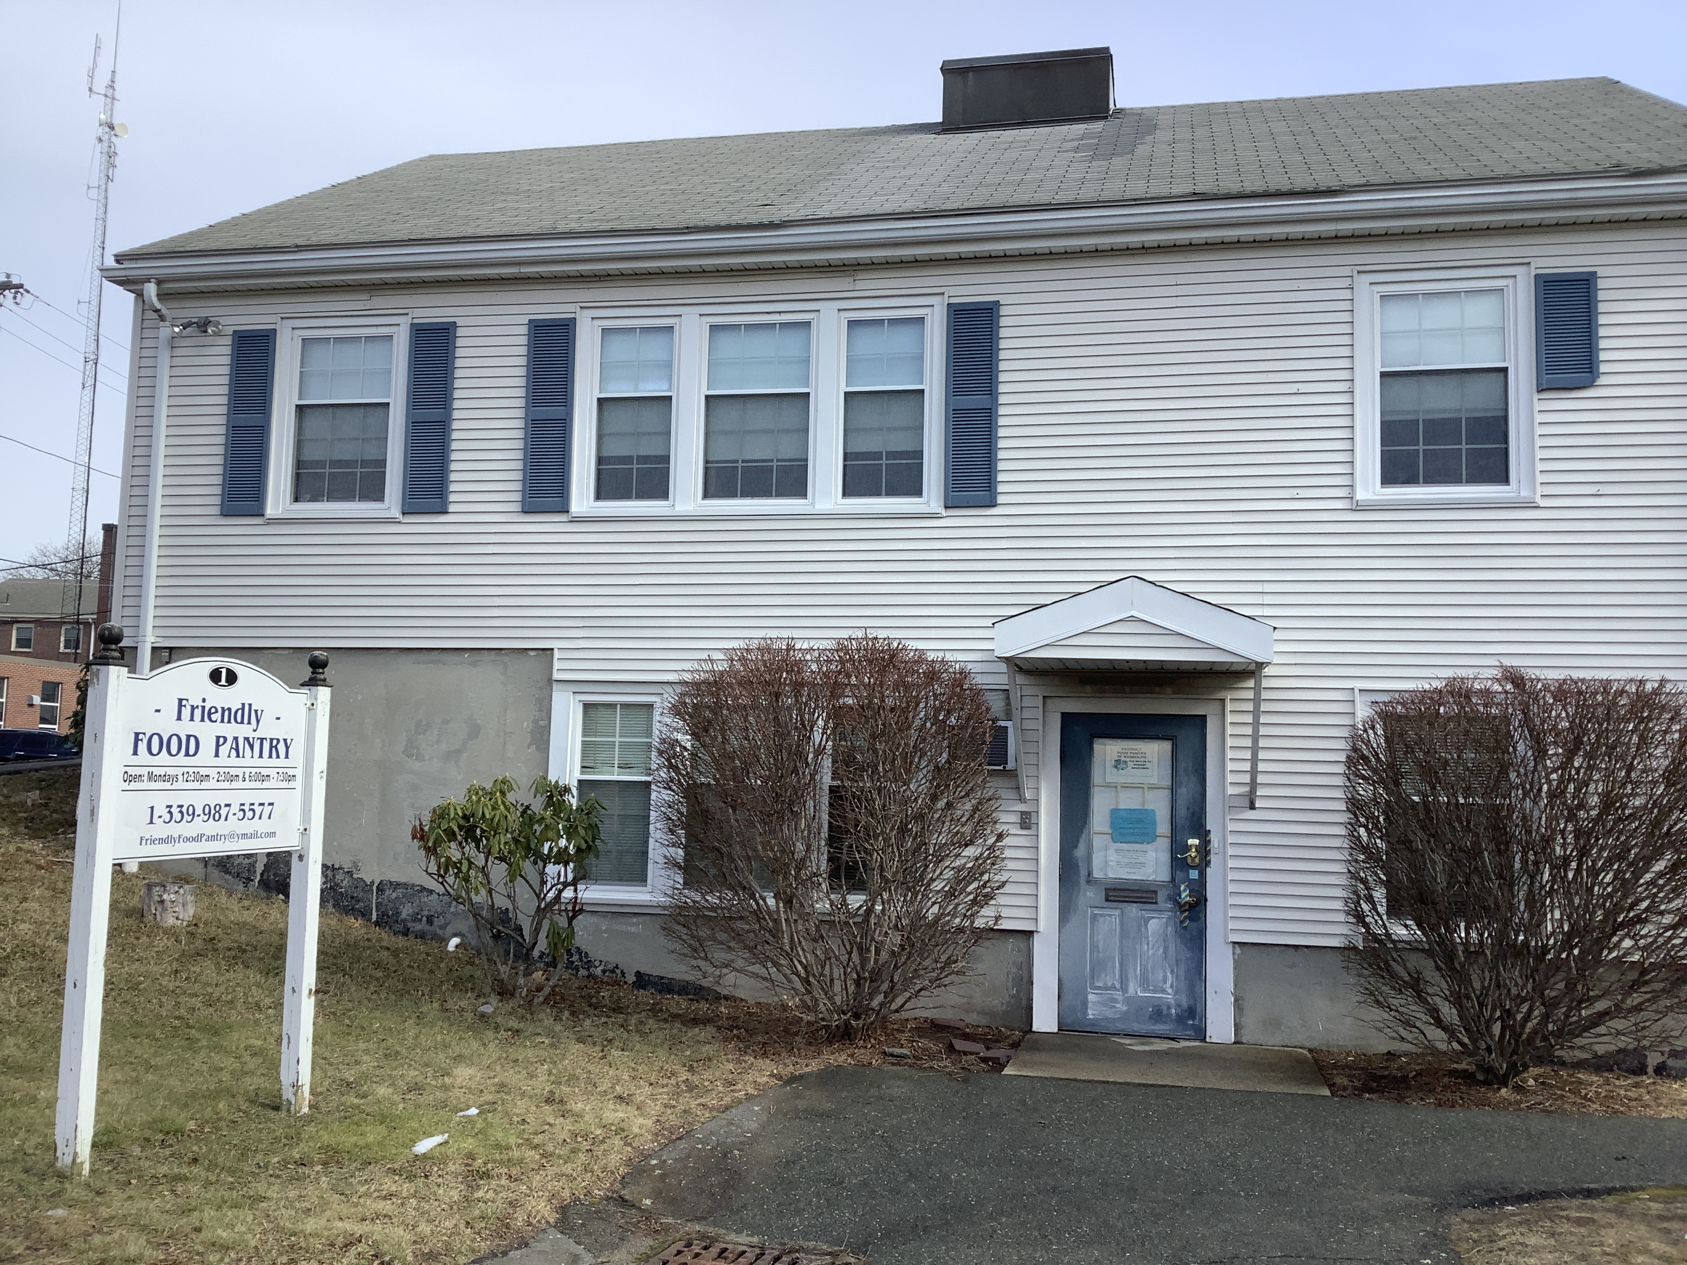

Town of Randolph
ADA Transition Plan
January 2023


560 Harrison Avenue, Boston, MA 02118
www.IHCDesign.org • info@IHCDesign.org
617-695-1225 voice

Background

Year Built: 1950’s

The Friendly Food Pantry is located at 1 Turner Lane. One (1) floor of the two (2) story building is used by the Food Pantry. The public accessible entrance is located on the west side of the building. There is a parking lot on the south side of the building.

On the first floor the Food Pantry has a lobby where the public can pick up donated food. Alternately, members of the public can request a service order number and be given their donated food outside.

Note: IHCD team only surveyed the areas used by the public.

Key Accessibility Issues

Parking
Accessibility issues include a Van Accessible parking space that lacks a sign with the International Symbol of Accessibility (ISA) and the designation "Van Accessible". Additionally, there is lack of an identification sign with the International Symbol of Accessibility (ISA) at a car accessible parking space.

Signage
Accessibility issues include lack of a tactile egress sign (with raised characters and braille) at the accessible exit (west side).

Note: If the exit sign at the main egress (west egress) door is replaced with an illuminated exit sign, provide an illuminated International Symbol of Accessibility (ISA).

Additional Accessibility Issues
- The main entrance door requires adjustment of the door closer, so the entrance door remains open 5 seconds minimum.
- Lack of the minimum required pull-side maneuvering clearance at the main egress (west egress) door.

Order of Magnitude Cost Estimates
- Miscellaneous corrective actions (egress signs): $432
- Reverse the swing of main entrance (west egress) door: $1,884

Total: $ 2,316
*Note: IHCD is not providing costs for accessibility renovation to outdoor areas.

