Corkin Building

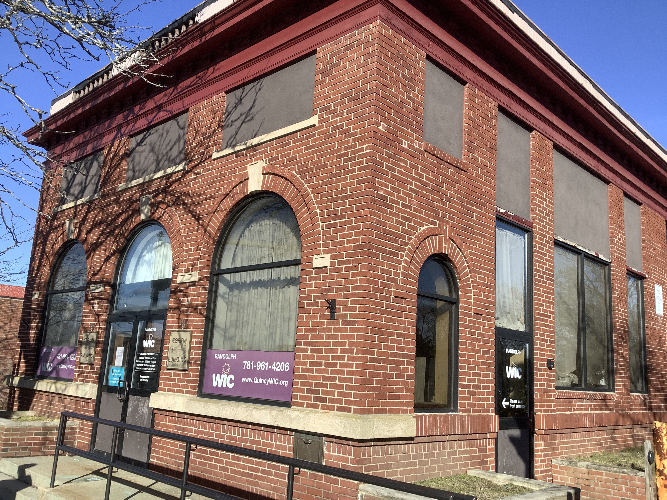

Town of Randolph
ADA Transition Plan
January 2023


560 Harrison Avenue, Boston, MA 02118
www.IHCDesign.org • info@IHCDesign.org
617-695-1225 voice

Background

Year Built: 1925 Years Renovated: 2004

The Corkin Building is located at 41 South Main Street. The two (2) story building is leased to the Randolph Women, Infants and Children (WIC) Program. Currently, only the first floor is occupied and the public accessible entrance is located on the west side of the building. There is on-street parking and an MBTA bus stop at the west side of the building.

The first floor consists of a lobby area, cubicle work areas, and a single-user toilet room.

Note: IHCD team only surveyed the areas used by the public.

Key Accessibility Issues

Exterior Ramp
Accessibility issues include a handrail that is located higher than is allowed and lack of handrail on one (1) side of the ramp.

Signage
Accessibility issues include lack of an egress sign (with raised characters and braille) and an illuminated sign with the International Symbol of Accessibility (ISA) at the main entrance (west egress) and lack of a designation sign (with raised characters and braille) at the single-user toilet room.
Note: If the exit sign at the main entrance (west egress) is replaced with an illuminated exit sign, provide an illuminated International Symbol of Accessibility (ISA).

Doors
Accessibility issues at the main entrance (west egress) and the single-user toilet room include two (2) doors with excessive opening force.

Single-User Toilet Room
Accessibility issues at the single-user toilet room include lack of a flush control on the open (transfer) side of the toilet, lack of a compliant toilet paper dispenser located below the grab bars, lack of insulated pipes at the lavatory and the paper towel dispenser is located higher than is allowed and acts as a protruding object. Additionally, the baby changing table lacks clear floor space due to the location of a chair and there is lack of a cane-detectable barrier at the paper towel dispenser.

Additional Accessibility Issues
- Lack of a secured mat at the egress door to the main entrance (west egress) and at the single-user toilet room.
- Lack of handrails at the exterior stair to the main entrance (west egress).
- Lack of required clear width to the cubicle work areas due to the location of a chair.

Order of Magnitude Cost Estimates
- Miscellaneous corrective actions (egress signs, relocate paper towel dispenser, relocate toilet paper dispenser, signage, etc.): $1,442

Total: $ 1,442
*Note: IHCD is not providing costs for accessibility renovation to outdoor areas.

