Powers Farm Community Park and Bertha Soule Memorial Park

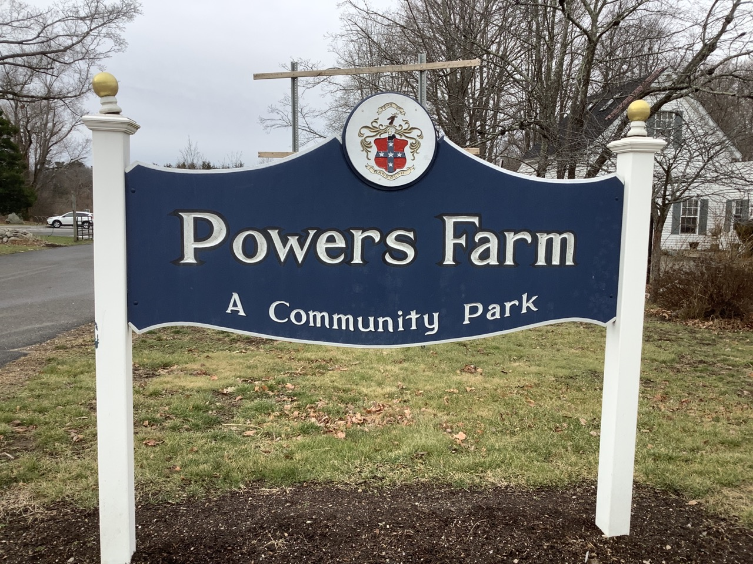

Town of Randolph
ADA Transition Plan
January 2023


560 Harrison Avenue, Boston, MA 02118
www.IHCDesign.org • info@IHCDesign.org
617-695-1225 voice

Background

Years Renovated: 2012, 2014, 2015

The Powers Farm Community Park and Bertha Soule Memorial Park are located at 592 North Main Street. This is a shared space for public markets, activities and events. The parks are connected by a series of boardwalk and stone dust walking trails. There is access to a paved parking lot, used by both parks, and an unmarked overflow parking lot.

The Powers Farm Community Park features a play area, a pavilion with picnic tables, men’s and women’s single-user toilet rooms, a drinking fountain, informational waysides, benches and a book-lending library. The Bertha Soule Memorial Park features boardwalk walking trails, benches, dam, and boat launch with a ramp and seating.

Key Accessibility Issues

Exterior Access Routes
Accessibility issues include lack of the minimum clear width at the trail pathways, routes not maintained in operable working condition and as a result, instances of water accumulation in the pathways. Other accessibility issues include lack of an accessible route to the amenities in the park including to the memorial bench along the Powers Farm trail, the bike rack; the book-lending library and the informational waysides. Accessibility issues at the play areas include excessive change in level at the entrances to the play areas and surface openings greater than the minimum allowed.

Parking Lot
Accessibility issues include lack of a car accessible parking space with a marked access aisle and a sign with the bottom located 60" min. above the ground and the International Symbol of Accessibility (ISA). Additionally, there is lack of a sign with the International Symbol of Accessibility (ISA) and the designation "Van Accessible".

Toilet Rooms
Accessibility issues at both the men's and women's single-user toilet rooms include lack of audible and visual fire alarms and two (2) doors with excessive opening force. Accessibility issues at the women's single-user toilet room include lack of maneuvering clearance at the toilet due to the location of a trash can and cooler.

Additional Accessibility Issues
- Lack of a drinking fountain provided for standing users.
- Lack of an 48" wide min. firm, stable and slip-resistant pathway around the playground.
- Lack of knee and toe clearances at least one (1) picnic table located at the pavilion.
*Note: IHCD is not providing costs for accessibility renovation to outdoor areas.

Best Practice and Inclusive Design
Best practice and inclusive design recommendations include elements that are not required in the standards but may create enhanced experiences for all users.
- At some instances along the Bertha Soule Memorial Park boardwalk walkway, there is a drop-off. Recommend providing a railing along the walkway.
- Recommend providing a 36” min. by 48” min. stable, firm and slip-resistant surface adjacent to at least one (1) bench located along the trailways that is located on an accessible route in a manner that is substantially similar to what is shown in Figure 1.

