Randolph Police Department

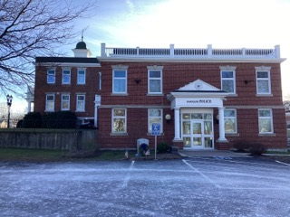

Town of Randolph
ADA Transition Plan
January 2023


560 Harrison Avenue, Boston, MA 02118
www.IHCDesign.org • info@IHCDesign.org
617-695-1225 voice

Background

Year Renovated: 1995 and 2009

Randolph Police Department is located at 41 South Main Street. The two (2) story building is home to the Police Department and the Town Hall. The building floors are connected by an elevator and a set of interior stairs. The public accessible entrance to the Police Station is located on the north side of the building. The entrance/exit used to transport detainees is located on the first floor (west side). The parking lot is shared with the Town Hall.

Note: See Town Hall report for additional accessibility issues at the parking lot.

On the first floor the Station houses a lobby area, a roll call and training room, an interview room a single-user toilet room by the lobby and women’s and men’s single-user toilet rooms near the break room. The detention area includes a detention interview area, a fingerprint area, eight (8) male holding cells including an accessible holding cell, one (1) accessible female holding cell and two (2) accessible juvenile holding cells – one of which has a lavatory/sink combo unit. All holding cells are located on the first floor. An emergency shower unit is located near the holding cells (Door #6).

Note: IHCD team only surveyed the areas used by the public.

Key Accessibility Issues

Single-User Toilet Room
Accessibility issues include side grab bars mounted lower than the minimum height allowed, paper towel dispensers mounted above the rear grab bar and mirrors mounted higher than the maximum height allowed.

Additional Accessibility Issues
- Lack of the designation "Van Accessible" at the sign located at the van accessible parking space and identification sign mounted lower that the minimum height allowed.
- Lack of clear floor space at the emergency shower due to the location of trash cans.
- Lack of a drinking fountain for standing users (by roll call area).
- Lack of an egress tactile sign (with raised characters and braille) and lack of the required illuminated exit sign with the International Symbol of Accessibility (ISA) at the accessible exit (north side).
- Lack of tactile stars on the elevator door jambs at the main egress level.
- Lack of an assistive listening system in the roll call and training room.

Note: Where a sound system, microphone and/or speaker are integral to the use of the space an assistive listening system (ALS) must be provided.

Order of Magnitude Cost Estimates
- Renovate toilet rooms: $2,662
- Provide a drinking fountain for standing users: $4,028
- Miscellaneous corrective actions (assistive listening system, egress signs, tactile star at elevator, etc.): $1,838

Total: $8,528
*Note: IHCD is not providing costs for accessibility renovation to outdoor areas.

Best Practice and Inclusive Design
Best practice and inclusive design recommendations include elements that are not required in the standards but may create enhanced experiences for all users.
- Recommend providing an automatic door opener at the main entrance to the Police Station. IHCD team was told that both officers and visitors would like an automatic door at the main entrance. While the exterior door did not require excessive opening force, IHCD team was told that some visitors have had difficulty with the door.
- Recommend providing a 36” min. by 48” min. stable and firm surface adjacent to the bench in a manner that is substantially similar to what is shown in Figure 1.

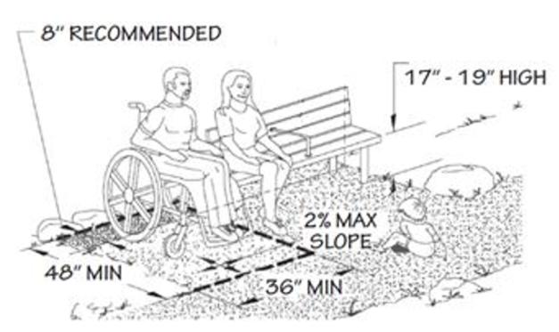
Fig. 1

- When renovation occurs, recommend locating the baby changing table 48" maximum above the finished floor (single-user toilet room by the lobby area).

