North Randolph Fire Station

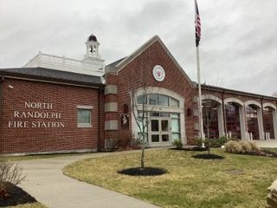
Town of Randolph
ADA Transition Plan
January 2023


560 Harrison Avenue, Boston, MA 02118
www.IHCDesign.org • info@IHCDesign.org
617-695-1225 voice

Background

Year Built: 2016

North Randolph Fire Station is located at 952 North Main Street. It is a one-story building that serves as a substation to the Central Fire Station. There are two (2) accessible entrances on the east side of the building and two (2) accessible exits on the west side of the building. Two (2) public parking spaces are located on the building’s south side.

Areas accessed by the public include the lobby, the first aid room, a single-user toilet room and the apparatus room when tours are given. IHCD team was told that the public visits occasionally for tours, and contractors may meet in the building, but most meetings including those with contractors take place at Town Hall.

Note: IHCD team only surveyed the areas used by the public.

Key Accessibility Issues

Single-User Toilet Room
Accessibility issues include lack of clear floor space at the lavatory.

Signage
Accessibility issues include lack of tactile egress signs (with raised characters and braille) and lack of an illuminated International Symbol of Accessibility (ISA) at the accessible exits.

Order of Magnitude Cost Estimates
- Renovate signage: $1296

Total: $ 1296
*Note: IHCD is not providing costs for accessibility renovation to outdoor areas.

