Moulton Street Parking Lot
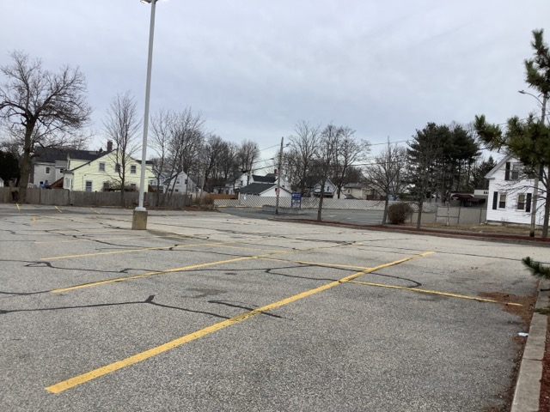
Town of Randolph
ADA Transition Plan
January 2023


560 Harrison Avenue, Boston, MA 02118
www.IHCDesign.org • info@IHCDesign.org
617-695-1225 voice/ tty

Background
The Moulton Street Parking Lot in Randolph is located at the corner of School Street. The parking lot extends from School Street to the edge of the CVS pharmacy located at 171 North Main Street.There are two vehicular entry/exit points on the northeast and southwest sides of the parking lot from the corner of School Street. There are 22 parking spaces with no accessible parking spaces.

Key Accessibility Issues

Parking
Accessibility issues include lack of a van accessible parking space with a marked access aisle, identification sign with the International Symbol of Accessibility (ISA) and a designation sign with the words, “Van Accessible.”

Order of Magnitude Cost Estimates

*Note: IHCD is not providing costs for renovations to outdoor areas.

