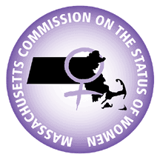
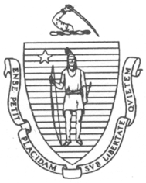
THE COMMONWEALTH OF MASSACHUSETTS
COMMISSION ON THE STATUS OF WOMEN

Eastern Regional Commission on the Status of Women and Girls
Meeting Agenda
Virtual

Date: Tuesday, March 28, 2023
Time: 7:00 PM-8:30 PM

Due to the ongoing COVID-19 Pandemic and State of Emergency, on March 12, 2020, Governor Baker issued an Executive Order Temporarily Suspending Certain Provisions of the Open Meeting Law, G.L. c. 30A sec. 20. Pursuant to the Order, public bodies are
temporarily relieved from the Open Meeting Law’s requirement that meetings be held in public places, open and physically accessible to the public, so long as measures are taken to ensure public access to the bodies' deliberations "through adequate,
alternative means."

Join Zoom Meeting
https://us06web.zoom.us/j/88419936252?pwd=VXhad2Z2cW04U0ZiTEFuNGFXemVEdz09

Meeting ID: 884 1993 6252
Passcode: 482733
One tap mobile
+13017158592,,88419936252# US (Washington DC)
+13052241968,,88419936252# US

Agenda for Meeting:
- Approval of Meeting Minutes
- Regional Chair Meeting Updates
- Listening Sessions
- Bylaws
- Commissioners’ inputs
- Public Input

Eastern Regional Commission on the Status of Women includes the towns of Avon, Brookline, Canton, Cohasset, Dedham, Foxborough, Holbrook, Hull, Milton, Plainville, Randolph, Sharon, Stoughton, and Westwood, and the cities of Boston, Braintree, Chelsea, Quincy, Revere, Weymouth, and Winthrop.

